3C7 Lab 1

Screenshot 1: Running the PWD command in the Vivado terminal

Screenshot 2:

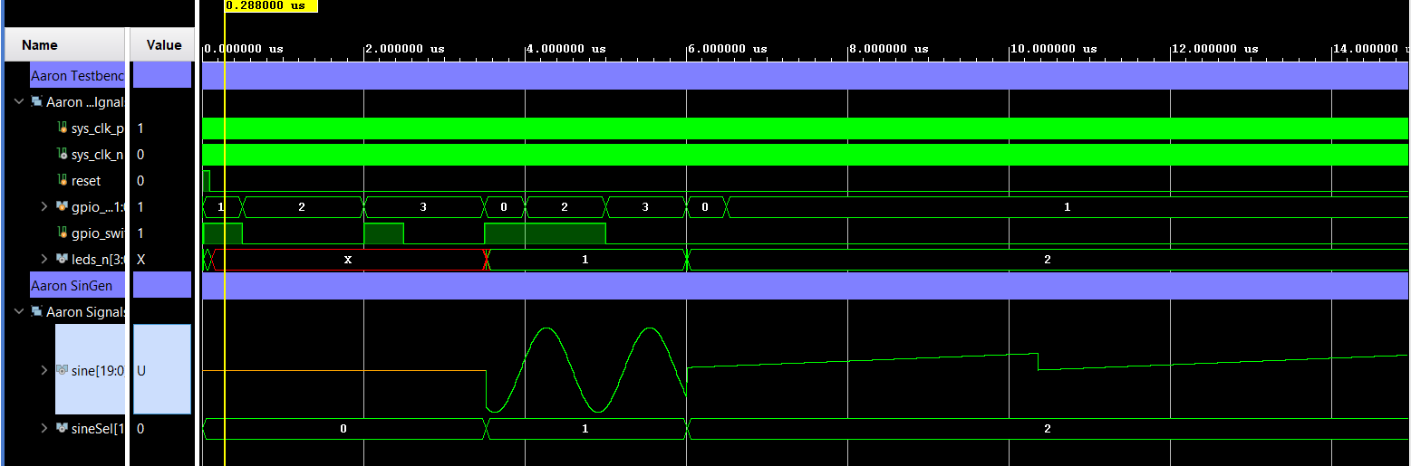

Screenshot 2 shows the testbench module running. We can see the sine wave start and then it devolves into a ramp function.

Screenshot 3 Mystery Module:

The screenshot above shows the output of the behavioral simulation of the mystery module. Looking at the output of the module we can see that when i0 and i1 are the same, the output, op, goes high. When i0 and i1 are different then the output is low. So this mystery module is a module that tests if its two inputs are the same. This can be achieved by a XNOR gate. So this module is implementing a XNOR gate.